**Setup Docker Network**

**1 this below command used to list down the networks**

docker network ls

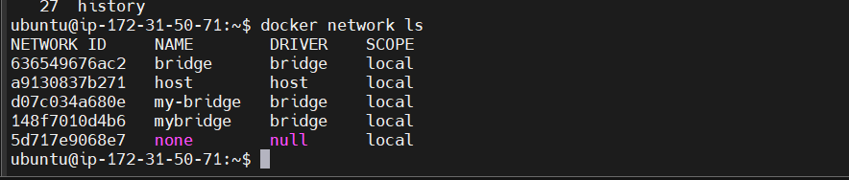

**2 create docker bridge network with the name my-bridge**

docker network create --driver bridge my-bridge



**3 now run nginx on newly created bridge network i.e my-bridge**

docker run --name web -d --network my-bridge nginx

**4 now to check nginx on which network used below command**

docker inspect web

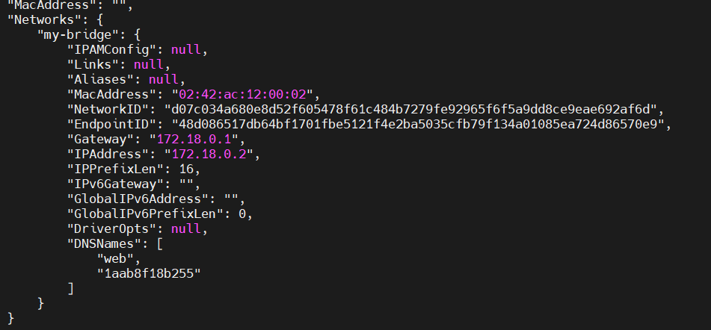

**5 you can also inspect network using below command**

docker network inspect my-bridge

**6 To delete the network use below command**

docker network rm my-bridge1

**note**

**if you get below error message then remove the container first**



Like this using rm –f command



**Create new network with name my-net as bridge network**

docker network create my-net

**7 Now how to connect nginx container to newly created bridge i.e my-net**

docker network connect my-net web

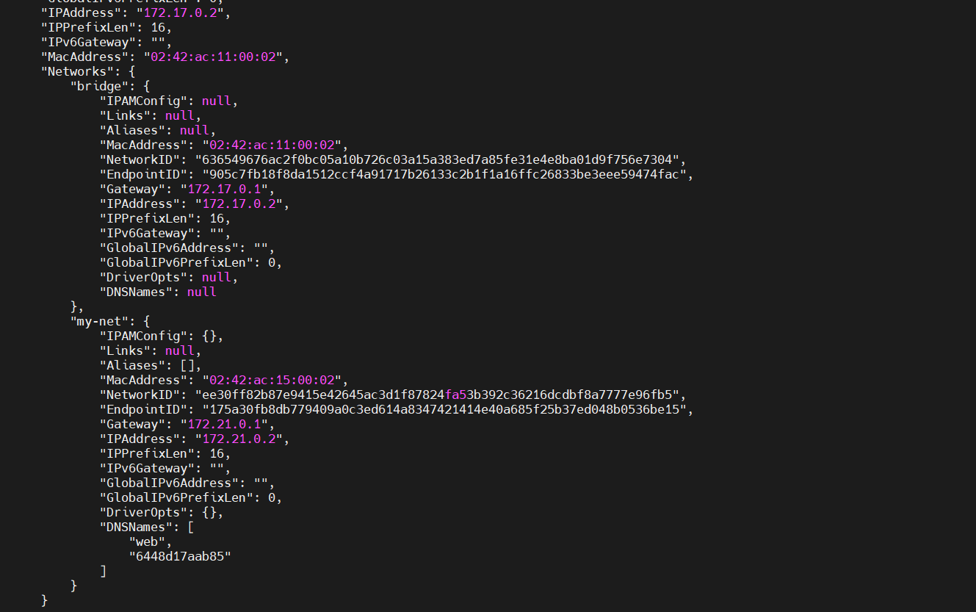

**8 you can disconnect to the network using simply disconnect command**

docker network disconnect my-net web

removed from network o/p

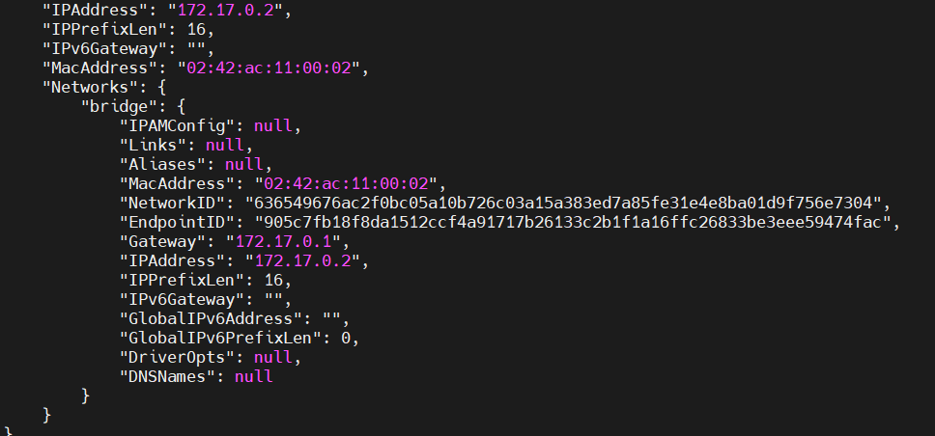

**Host Network**

**9 host nginx in host node using following command**

docker run --name web -d --rm --network host nginx

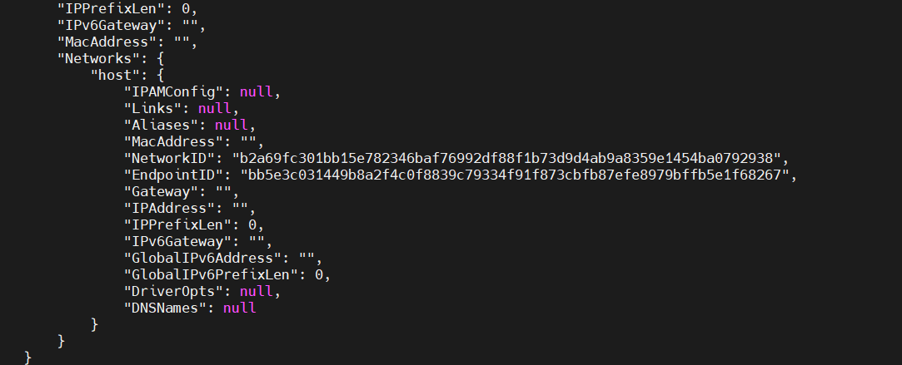

**10 to test nginx hosted properly by using following command**

curl localhost

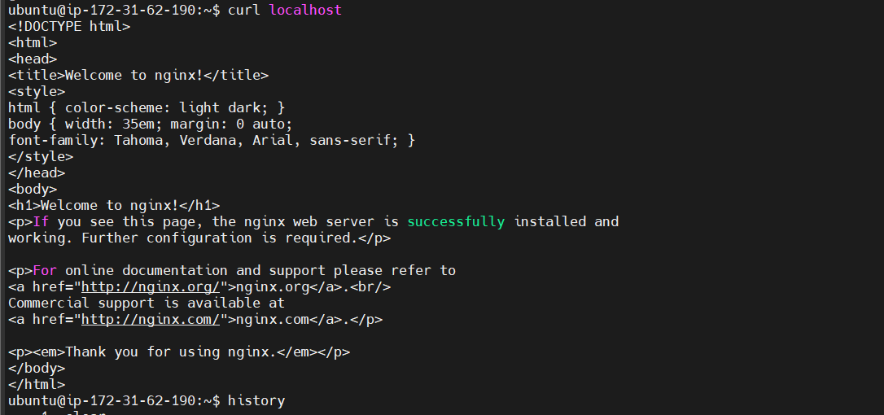

**MACVLAN Network Setup**

**1 create macvlan network using below command**

docker network create -d macvlan --subnet=172.16.86.0/24 --gateway=172.16.86.1 -o parent=docker0 macvlan

**2 run nginx on top os macvlan network**

docker run --name web -d --network macvlan nginx

**3 Now inspect weather nginx in configured on macvlan**

docker inspect web

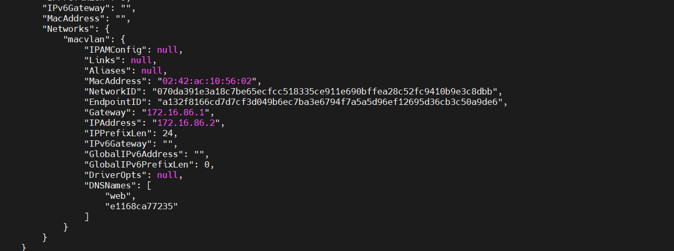

**None Network**

**1 How to setup nignx on none network**

docker run --name web1 -d --network=none nginx

**2 To inspect use below command**

dockerinspect web1

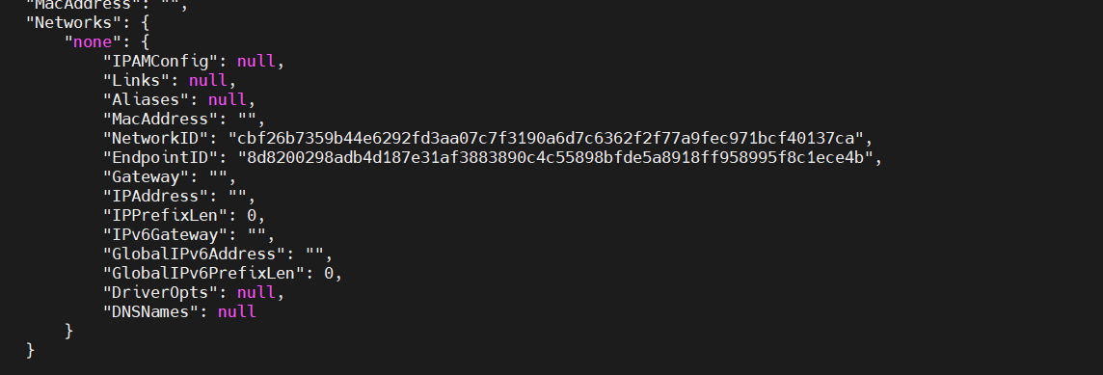

As per observation there is no ip address no gateway, no dns

**We can cleanup docker network when no container are running on network inthis case macvlan have running not container so it will get deleted when we use praune command**

**Note: its same concept like dangling images**

docker network prune

o/p

